Back to the Boulevard 2nd Annual Show, Shine & Cruise

Car Club Banner Sponsorship

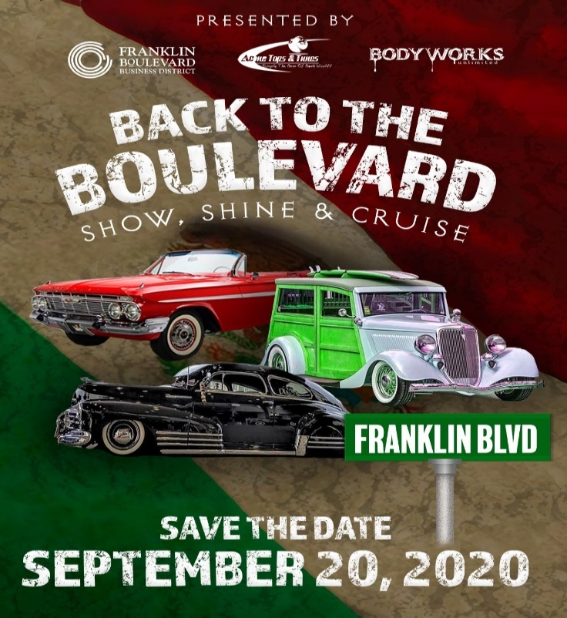
The Franklin District is excited to announce that the Back to the Boulevard Show, Shine & Cruise will be taking place Sunday September 20, 2020. We would like to thank all of those that participated in last year’s cruise and helped make it a historical event for our city.We also would like to mention that at last year’s event, car clubs were able to sponsor event banners that were displayed along the district. The car club banner sponsorships we will be available this year and will be displayed along the extended cruise route from 12thAve to Fruitridge Rd.This is a great opportunity for car clubs to promote themselves and show their support.
Exclusive Car Club BannerSponsorship$500:

- Logo placed on event t-shirts and posters
- Car club promotion on street pole banner (18x38)for the remainder of the year
- Car clubs receive an additional banner as a memento

**************************************************************************************
Car Club Information

Car Club Name: __________________________________________________________________

Contact Name: ___________________________________________________________________

Phone: __________________________________________________________________________

E-Mail:__________________________________________________________________________

**Please note the car club banner sponsorships are due no later than June 30,2020**
Car club banner sponsorships are limited and on a first come basis**
If interested please contact: info@backtotheblvd.com

